**Geometry Vocabulary Test Review**

1. On a number line, the coordinates of A and B are -11 and 34, respectively. What is the coordinate for the   
    midpoint of $\overline{AB}$? (Show the algebra you used to find the midpoint.)
2. The three building blocks of geometry are: __________, __________, and __________.  
    **Explain** why these “building blocks” are considered to be undefined.

1. Complete the statements below. Then, write the letter for each statement under the correct picture.
2. Through any __________ noncollinear points there is exactly one plane.
3. If two lines intersect, then their intersection is exactly one _____________.
4. If two ___________ intersect, then their intersection is a line.
5. Through any two points there is exactly one __________.

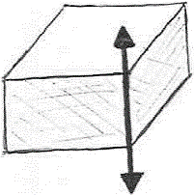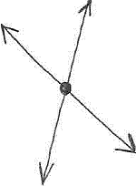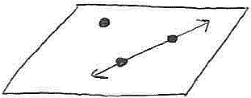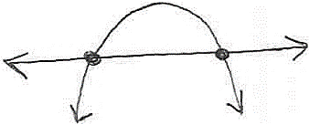

________ ________ ________ ________

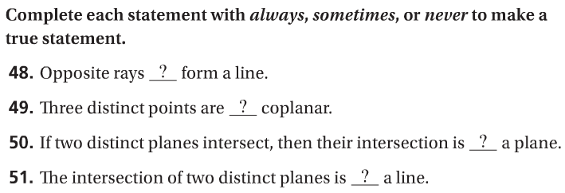

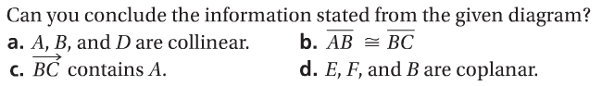

1. 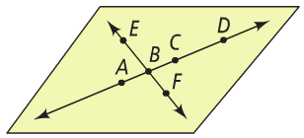

CHALLENGE QUESTIONS:

1. C is the midpoint of , D is the midpoint of , E is the midpoint of , F is the midpoint of   
    , G is the midpoint of , and H is the midpoint of . If DC = 16, what is GH?   
    (Hint: Draw a picture…start with  which will need to be really long!)

1. 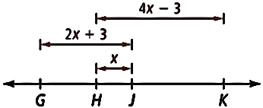 Use the diagram at the right.  
    a) What algebraic expression represents GK?  
     
     
     
    b) If GK = 30, what are GH and JK?