Name Date Period

Find the missing side length(s) below using two strategies:
- Method 1: Use the scale factor from one figure to the other
- Method 2: Use ratios of the side lengths within each figure (proportions).

A
1.5 cm

3 cm x
6 cm

5 cm

12 cm

Scale Factor: Proportion:

B
6 cm
x

1.5 cm

10 cm
Scale Factor: Proportion:

C
d e
68°
a
c
b
12.5 m

18.75 m
27.5 m

68° f
x
Scale Factor: Proportion:

D
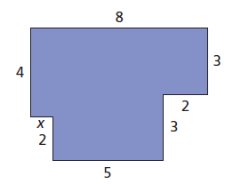
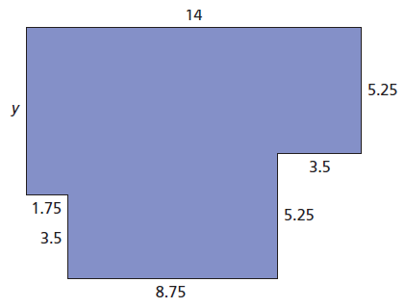
Scale Factor: Find x Proportion: Find y

