Name: _____________________________ Date: ________________ Period: ______

Core Math Idea: How can you use scale factors to find missing side lengths?

- Rectangles ABCD and EFGH are similar. Find the length of side AD. Explain how you found the length.
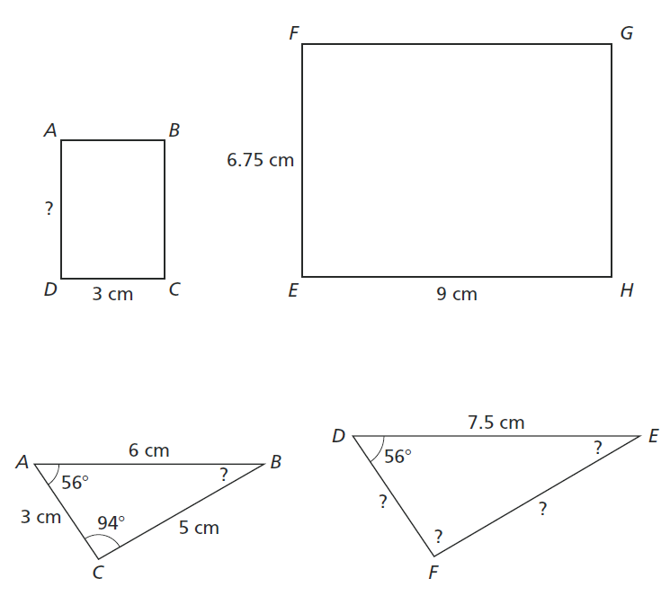

- Triangles ABC and DEF are similar. Find the missing side lengths and angle measures. Explain.

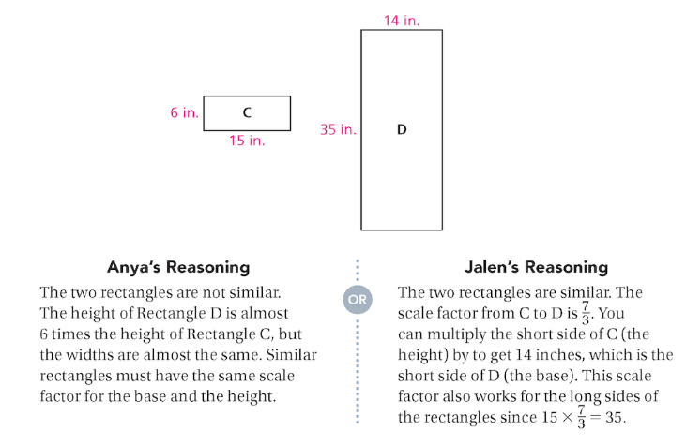
- Anya and Jalen disagree about whether the two figures below are similar. Do you agree with Anya or Jalen? Explain.

- Melanie and Wyatt discuss whether the two figures at the below are similar. Do you agree with Melanie or Wyatt? Explain.

