Name:____________________________________ Date:___________ Period:________

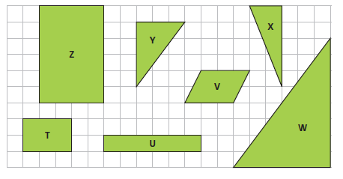

- Name all the pairs of similar shapes. Explain how you know they are similar.

- For each pair of similar figures, find the scale factor in both directions. Sketch a picture or label them in the picture above.

- List two pairs of non-similar shapes and explain how you know they are not similar.
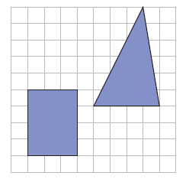
a. Draw a rectangle that is similar, but not identical, to the given rectangle.

b. Draw a triangle that is similar, but not identical, to the given triangle.

c. How do you know the figures you drew are similar to the original figures?

