Target- 7.G.2

I can construct triangles from three given angle measures to determine when there is a unique triangle, more than one triangle or no triangle using appropriate tools. Grade: _______

1. A triangle has sides of 7 and 12 units. The measurement of the longest side is missing.  
Herbert says that one possibility for the unknown side length is 17.

Do you agree with Herbert? Why or why not?

2. Use the figure below which shows parallel lines and a transversal.  
The measure of 2 is 62°. Find the measures of angles 1, 3, and 6.  
Explain how you found each measure.



**a.** Measure of 1 = Explain:___________________________________________________

__________________________________________________________

**b.** Measure of 3 =

Explain:____________________________________________________

__________________________________________________________

**c.** Measure of 6 =

Explain: _____________________________

__________________________________________________________

**3**. Use the figures below.

**a.** **Draw** an adjacent angle that will make a complementary angle to the one below. **Describe** how you know it is a complement.

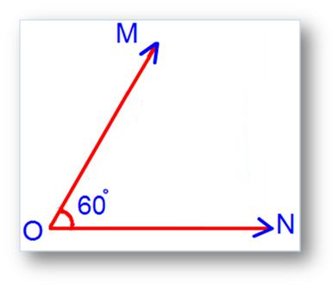 Complement: ________________

**b.** **Draw** an adjacent angle that will make a supplementary angle to the one below. **Describe** how you know it is a supplement.



Supplement: ________________

**4.** Is it possible for a triangle to have a 54° angle and a 116° angle? Explain why or why not.

There will be a constructing triangles section on the summative!

**THIS SIDE IS NOT REQUIRED! BUT IT IS AWESOME EXTRA PRACTICE ☺**

3. Draw a triangle *DEF* with D = 50°, DE= 7 cm, and *E* = 80°.

4. Draw a triangle *ABC* with *AB* = 5.5 cm, *BC* = 9.5 cm, and *ABC* = 78°.

5. Draw a triangle BCD with BC = 8 cm, CD = 8 cm and BD = 4 cm.

**Explain** what type of triangle this is and how you know you constructed it correctly.