Target: 7.G.5
I can use facts about supplementary, complementary, vertical and adjacent angles in a multi-step problem to write and solve simple equations for an unknown angle in a figure. (use facts) MAS ADV MTS APP BEG

1a. Draw an example of complementary angles. 1b. Find the missing angle measure.
Explain how you know they are
complementary.
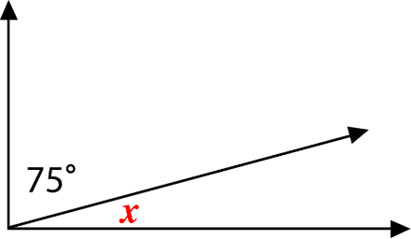

2a. Draw an example of supplementary angles. 2b. Find the missing angle measure.
Explain how you know they are
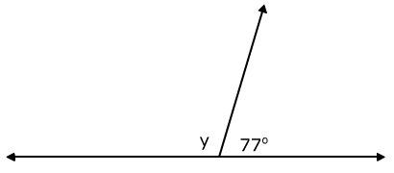
supplementary.

- Use the figure below.
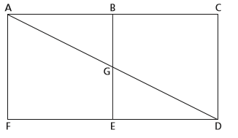
- Name one angle that is
complementary to EDG.

- Name one angle that is supplementary to AGE.
T

- Is it possible for a triangle to have a 85° angle and a 55° angle? Explain why or why not.

- For each polygon, find the missing angle measure. Show your work!

This polygon is a regular nonagon.
140°
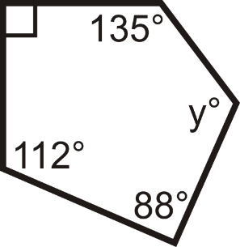

b°

How do you know?

- Use the quadrilateral below. Find the measures of angles 1,2,3, and 4.
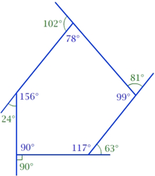
1

Measure of angle 1 _________
Measure of angle 2 __________
4

Measure of angle 3 _________
2

Measure of angle 4 ___________
3

b. Explain how you know that the measures in part (a) are correct without using an angle ruler or protractor.

5. What is the interior angle sum of a 13-sided polygon? Show your work.

