Shapes and Designs Investigation 1 Summative Review
I can use facts about supplementary, complementary, vertical, and adjacent angles in a multi-step problem to write and solve simple equations for an unknown angle in a figure. (CC7.G.5)

Name: ____________________________________ Date: ___________ Period: _____ Score:_______

1.
Explain how you know you made an accurate estimate.

4. Estimate the measure of each angle in degrees. Name each type of angle and give your estimate.

5. What is a polygon? Draw two examples.

6. Snowboarders use angle measures to describe their flips and spins. Explain what a snowboarder would mean by completing a 540.

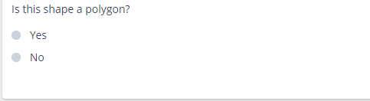
7.
How do you know?

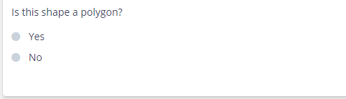
8.
How do you know?

There will be a portion of the test that requires you to find the exact measure of angles. Make sure you know how to use an angle ruler or protractor.

