Name: _____________________________ Date: ________________ Period: ______

Core Math Ideas: What is an exterior angle of a polygon?
What do you know about the measures of exterior angles?

The figures below show two ways to form exterior angles. You can extend the sides as you move in either direction around the polygon.

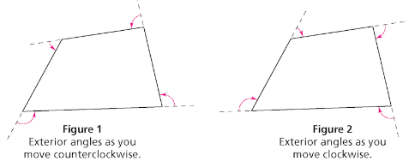

A. Members of the Columbia Triathlon Club train by bicycling around the polygonal path shown.
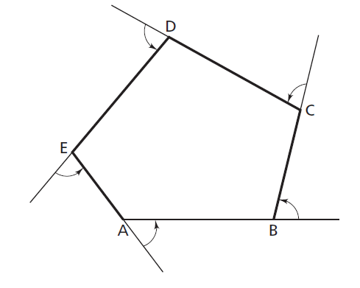

What is the sum of the left-turn exterior angles?

1. Make a conjecture without measuring and explain why you made an accurate estimate.

- Check your conjecture by measuring each angle.
B. Find the exterior angle sum of triangular path below. Show all your work.

C

A
B

How does the exterior angle sum of the triangle compare to the exterior angle sum of the pentagon from the first page?

____________________________________________________________________________
Homework:

Will the turning pattern you observed in cycling around several polygons occur in any other polygons? Why or why not? Draw one other polygon and find the exterior angle sum to prove or disprove your conjecture.

