Name: _____________________________ Date: ________________ Period: ______

Core Math Idea: How can you use the pattern between the number of sides and the angle sum to calculate the measure of an angle in a regular polygon?

Warm – Up:
Tell whether each figure is a polygon. Explain how you know.
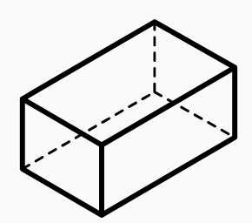

_____________________________________________________________________________

Good to know!
A regular polygon is a polygon in which all of the sides are the same length and all of the angles have the same measure.

Draw an example of a regular polygon (with less than 6 sides) and estimate the measure of one of the angles. Be ready to share!

How could you find the total angle sum of the shape you drew above?
- Use an angle ruler to measure the angles in the equilateral triangle, the square, the regular pentagon, and the regular hexagon from the Shapes Set.
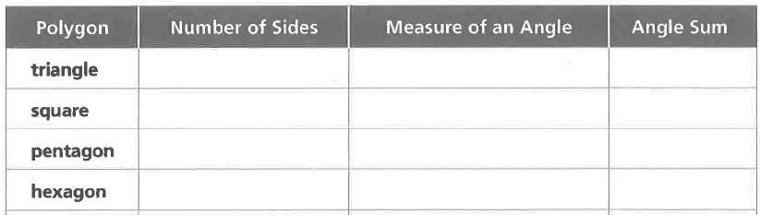

- Describe a pattern that your table group noticed about the triangle, square, pentagon, and hexagon.
1.
2.
3.

4.

- Describe a pattern that your table group noticed about the triangle, square, pentagon, and hexagon.

- Use the pattern you noticed to fill in the table for regular polygons with seven, eight, nine, and ten sides. Check to see if your pattern works for the heptagon (E) and the octagon (F) by measuring the angles.
7

8

9

10

______________________________________________________________________________
Homework:

Predict the angle sum for a 12-sided regular polygon. Explain how you got your answer.

What would the measure of each angle be for a 12-sided regular polygon?

