Angle Pairs Practice Work Name: ____________________________________
Pg. 38 #7-26 Date: __________________ Period: ____________

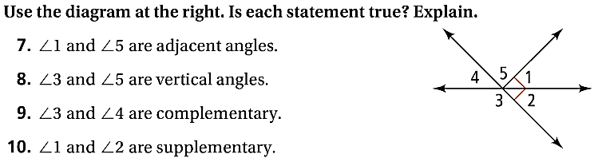

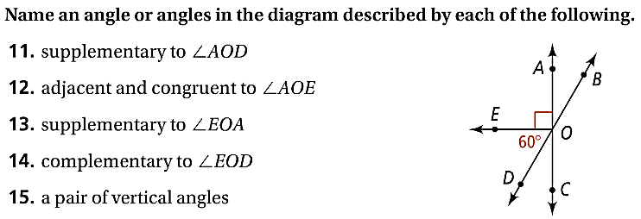

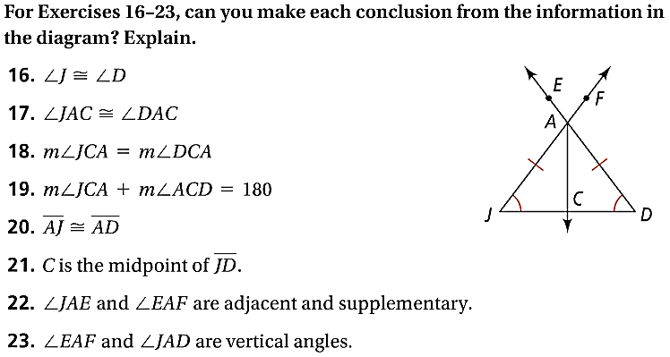

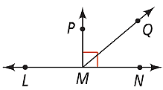
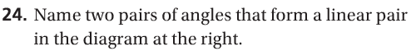

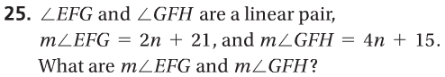

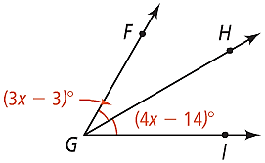
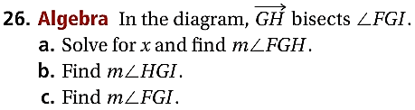

Angle Pairs Practice Work – Con’d Name: ____________________________________
Pg. 38 #31-36, 38, 41 Date: __________________ Period: ____________

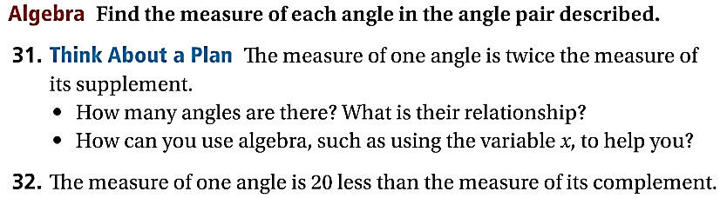

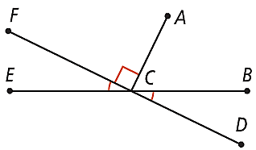
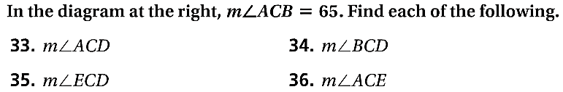

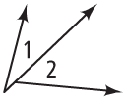

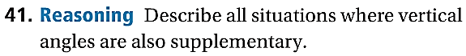

Even More Angle Pairs Practice Name: ____________________________________
Pg. 38 #27-28, 39, 40, 46-48, 53 Date: __________________ Period: ____________

