**Use PROPORTIONS to solve each of the following situations.**

**Be sure to do the following:**

* **Label the numbers in your proportions**
* **Include a variable in your proportions to represent the unknown value**
* **State your answer in a complete sentence.**

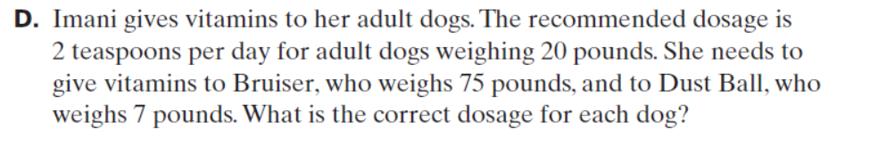**1.**



**2.**



**3.**

4. The triangles in the picture below are similar. Find the height of the tree.