Name_______________________________ Date: _______ Period______

**Learning Targets**

I can solve addition problems involving rational numbers. MAS ADV MTS APP BEG

**Number Lines**

For **1** and **2**, on the number line below, please plot each of the following rational numbers ***and*** **their opposites**.

$-1\frac{1}{2}$, 4, 3.5, 8.25

dy-number-line-09-und

For **3** and **4**, insert <, >, or = to make a true sentence.

3a). -9 9 3b). -10 -1

4a). -301 -300 4b). -2 -14

**5.** On the number line below, sketch the values of *x* when *x* > -4.

dy-number-line-09-und

**6.** On the number line below, sketch the values of *x* when *x* ≤ 2.

dy-number-line-09-und

**In the following problems, be sure to write a complete number sentence. Use the number lines as needed.**C:\Documents and Settings\carla.dahlin\Local Settings\Temporary Internet Files\Content.IE5\0ENXJZEI\MC900436690[1].wmf

**7.** In Juneau, Alaska, the temperature was the temperature -18° F. The temperature increased 15° F.



Number sentence: ________________

**8.** In Lansing, Michigan the temperature was 5° F. It later decreased 26° F.



Number sentence: ______________

**Chip Model**

For **9-11**, Use this chipboard as the starting value for **each part**.

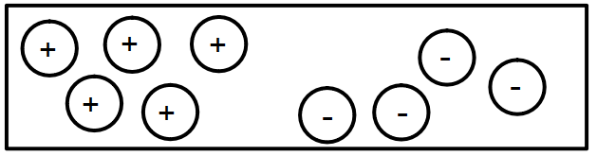

**\*\*\*Find the total value on each chipboard. Write a number sentence for each part.**

**9.** What is the value of the **original** chipboard?

Number sentence: _______________________

**10.** What is the value if you **add 2 positive** chips to the original board?

Number sentence: _______________________

**11**. What is the value if you **remove 3 negative** chips from the original board?

Number sentence: _______________________

**For 15**, **start** with only 4 negative chips on the board. **Describe in words** how you would **subtract 7 negative** chips and write a number sentence that shows your answer.

My number sentence: _______________________