Learning Targets:
I can solve addition problems involving rational numbers. MAS ADV MTS APP BEG
I can solve subtraction problems involving rational numbers. MAS ADV MTS APP BEG
Predict (without solving) whether the following result will be positive, negative or zero. You must explain your answer!

1) -1668 + 292 3) 393 $-^{-}$ 499

2) -8 $\frac{1}{3}$ + 8 $\frac{1}{3}$ 4) -89 – 15

Addition and Subtraction of Rational Numbers

5) -2 + -3 11) 8 – 7 + 4 17) $\frac{3}{4}$+ $\frac{7}{8}$

6) -5 + -5 12) -15 + -11 18) -5.5 + -1.5

7) 25 + -15 13) -21 + 40 19) $-2\frac{1}{2}$ +$\frac{1}{8}$

8) 10 - 8 14) 2 - 10 20) 2.5 - 4.5

9) -6 - (-7) 15) -2 - (-10) 21) -$2\frac{1}{2}$- ($-\frac{1}{4}$)

10) 20 - (-12) 16) -22 - 15 22) $-\frac{2}{3}$ - $\frac{1}{4}$

Answer the following question with ‘true’ or ‘false’ and explain your answer. (You may use pictures, number lines and/or words)

23) The sum of a positive number and a negative number is always negative.

24) If a positive integer is subtracted from a negative integer, the difference is a negative integer.

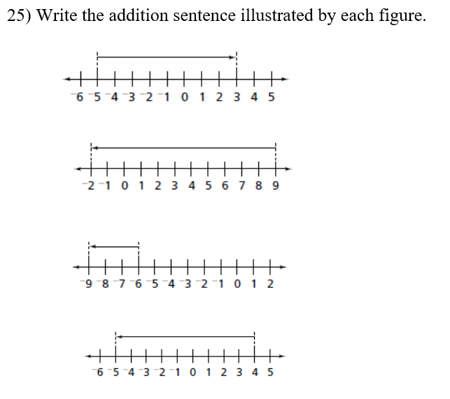
Number Sentence: __________________________
Number Sentence: __________________________
Number Sentence: __________________________
Number Sentence: __________________________

