Name: _________________________________ Date: _______________ Period: _____

Write and solve a number sentence for each situation. Use positive numbers for running speeds to the right, and use negative numbers for running speeds to the left. Use positive numbers for time in the future, and use negative numbers for time in the past.
(Note: Each runner runs at a constant speed)

- Hahn passes the 0 point running 5 meters per second to the right. Where will he be 6 seconds later?
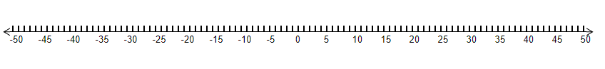

Number Sentence: _____________________

- Aurelia passes the 0 point running to the left at 6 meters per second. Where will she be 8 seconds later?

Number Sentence: _____________________

- Dwayne passes the 0 point running 4 meters per second to the right. Where was he 6 seconds earlier?

Number Sentence: _____________________

- Tori passes the 0 point running to the left at 5 meters per second. Where was she 7 seconds earlier?

Number Sentence: _____________________

