At one point in a game, the scores are as follows:

-500
500
0

- Which team has the highest score? Which team has the lowest score? Explain.

B. How many points would the losing team need to score to catch up to the team that is ahead? (How many points are in-between the two teams?)
- Super Brains and Rocket Scientists ___________

- Super Brains and Know-It-Alls___________

- Rocket Scientists and Know-It-Alls__________

C. The current scores are -300 for Super Brains, 150 for Rocket Scientists, and -500 for Know-It-Alls

- Write number sentences to represent how the rest of their game went to determine their final score.
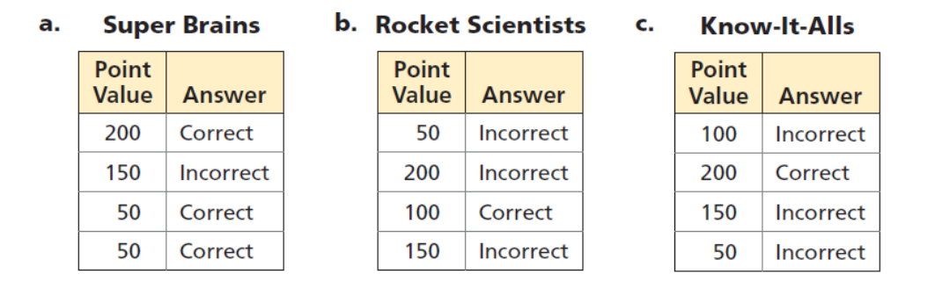

- Super Brains: _________________________________
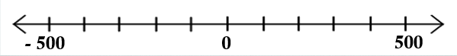

- Rocket Scientists: ______________________________________

- Know-It-Alls: __________________________________________

- If this was the end of the game, which team won? Which team lost? How do you know?

D. The number sentences below describe what happens at a particular point during a game of Math Fever. Find each missing number.

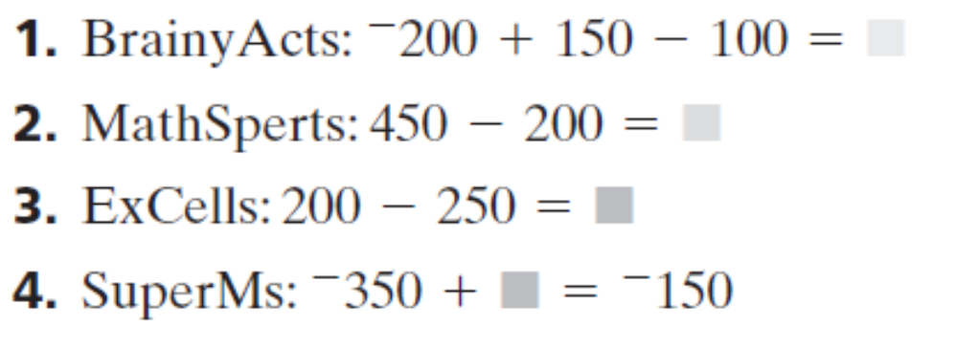

E. Sam forgot to record a score. Sam wrote this number sentence:

⁻350 + ___ = ⁻450 What score goes in the box?

F. Find three different pairs of numbers that have a sum of ⁻150.

____ + ____ = ⁻150

