Triangle Congruency Theorems Practice Name: _________________________
Date: ______________ Period: _____

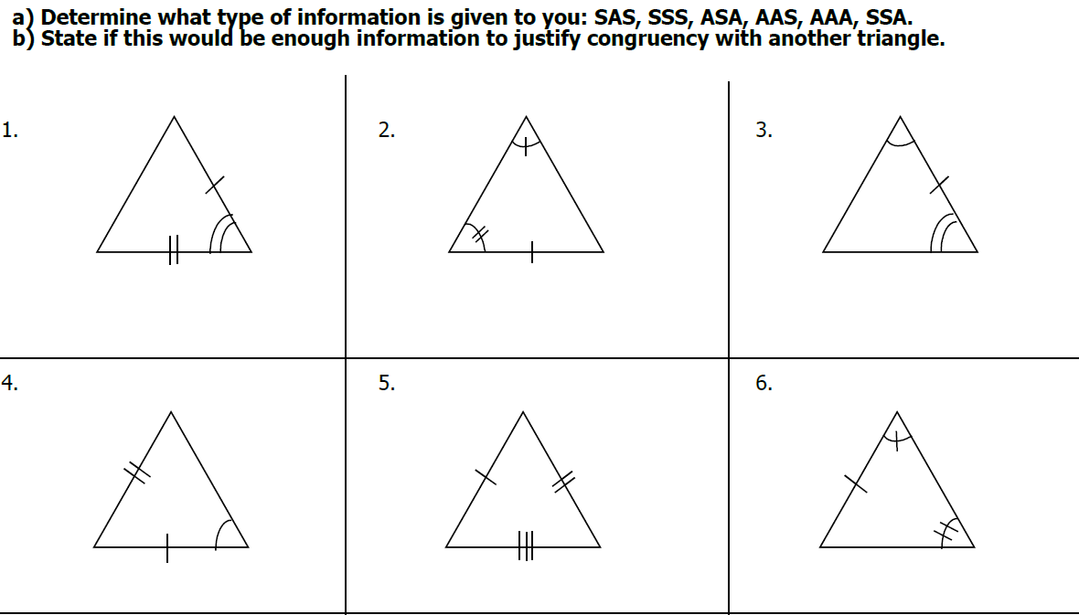
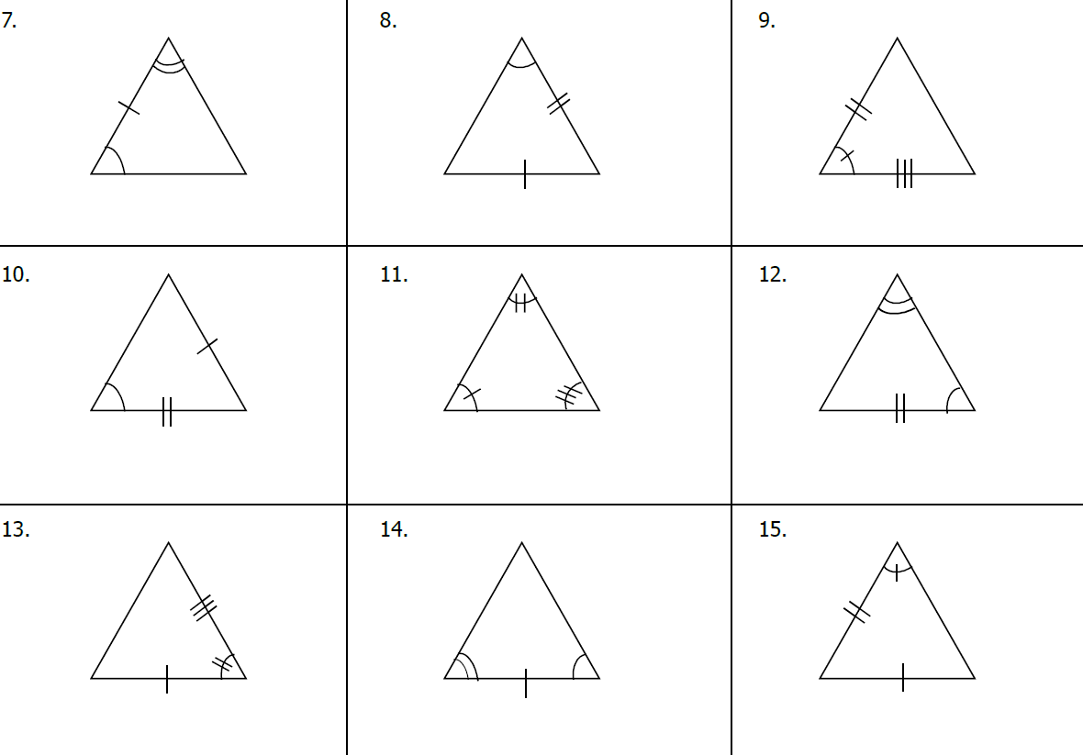

Congruent Theorems Puzzle: ASA, AAS, SAS, SSS
For each problem, give the correct naming order of the congruent triangles. Then, write that name (in order) on the lines for the problem number (see box at bottom). Also, indicate which postulate or theorem is being used.
W
A
B
I
C
R
B
C
G
A
N
B
A
S
C
E
G
J
R
H
E
C
A
E
B
Y
C
B
S
A
D
O
M
K
N
A
H
T
A
T
H
C
B
I
A
L
K
J
T
L
H
D
F
S
E
N
H
A
A
B
C
G
A
K
A
B
Y
C
D
P
E
S

ΔABC ≅ Δ _______ by _________

ΔABC ≅ Δ _______ by _________

ΔABC ≅ Δ _______ by _________

ΔABC ≅ Δ _______ by _________

ΔGHJ ≅ Δ _______ by _________

ΔABC ≅ Δ _______ by _________

ΔDEF ≅ Δ _______ by _________

ΔABC ≅ Δ _______ by _________

ΔJKL ≅ Δ _______ by _________

ΔABC ≅ Δ _______ by _________

ΔABC ≅ Δ _______ by _________

ΔMNO ≅ Δ _______ by _________
1. 2. 3.

4. 5. 6.

7. 8. 9.

10. 11. 12.

___ ___ ___ ___ ___ _O_ ___ ___ _N_ ___ ___ ___ _S_ ___ ___ _E_ ___ _I_ ___ ___ ___ ___ ___ _T_ ___
4 4 4 8 8 8 12 12 12 2 2 2 5 5 5 9 9 9 6

___ ___ ___ _E_ _E_ ___ ___ ___ _O_ ___ ___ _N_ ___ _U_ ___ ___ ___ ___ _T_ ___ _E_ ___ ___ _I_ ___ .
6 6 10 10 10 1 1 1 3 3 3 7 7 7 11 11 11
(When you are done with the puzzle, there are: 3 SAS, 5 AAS, 2 ASA, and 2 SSS instances.)

