Name: ________________________________________ Per: ______ Date: ____________________

**Practice: Proofs of Congruent Triangles**

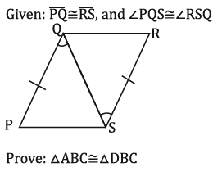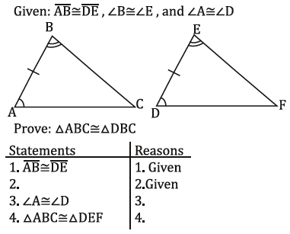**Fill in any missing statements or reasons.**

**2)**

**1)**

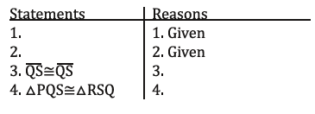

SQ

**Prove: Δ QPS ≅ Δ SRQ**

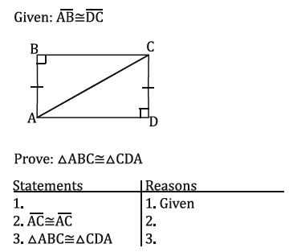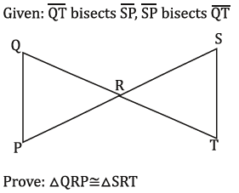

CD

**4)**

**3)**



CA

AC

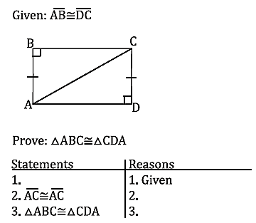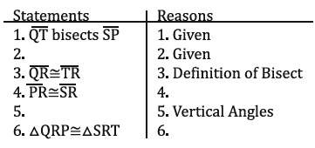

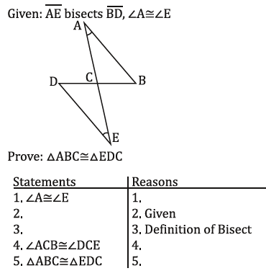

**5)**

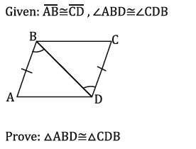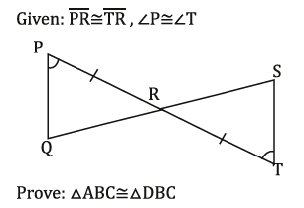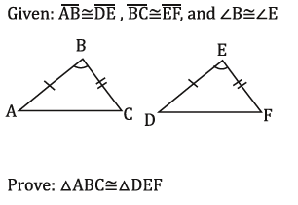

**Statements Reasons**

**Prove: Δ PRQ ≅ Δ TRS**

**Statements Reasons**

**Statements Reasons**

**8)**

**7)**

**6)**