Name: __________________________________________ Date: _____________________ Period: _______

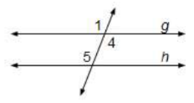
PRACTICE: PROOFS ~ CONVERSES AND PARALLEL LINES

- Given: ∠ 5 ∠ 4
Prove: g//h (w/o converse of AIA Th)

Conclusions Justifications
- 1)

- 2)

- 3)

- 4)
m
n
1
3
2
4
5

- Given: ∠ 2 ∠ 4
Prove: m//n (w/o converse of CAP)

Conclusions Justifications
- 1)

- 2)

- 3)

- 4)
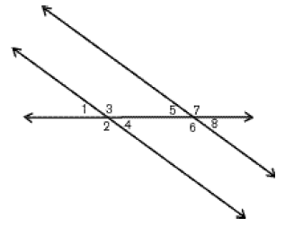
a
b

- Given: ∠ 1 ∠ 8
Prove: a//b (w/o converse of AEA Th)

Conclusions Justifications
- 1)

- 2)

- 3)

- 4)
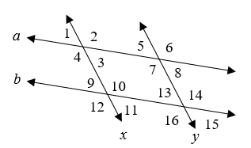
- Given: a//b, x//y
Prove: ∠ 3 ∠ 13

Conclusions Justifications

- Given: ∠ 6 ∠ 12 and x//y
Prove: a//b

Conclusions Justifications

CHALLENGE: Please try this.
m
n
1
3
4
5
- Given: ∠ 1 ∠ 4
Prove: m//n (using Converse SSIA Theorem)
*(Hint: Consider using Substitution…)

Conclusions Justifications

