Name: __________________________________ Period: ______ Date: _________________

**“Introduction to Proofs” Practice**

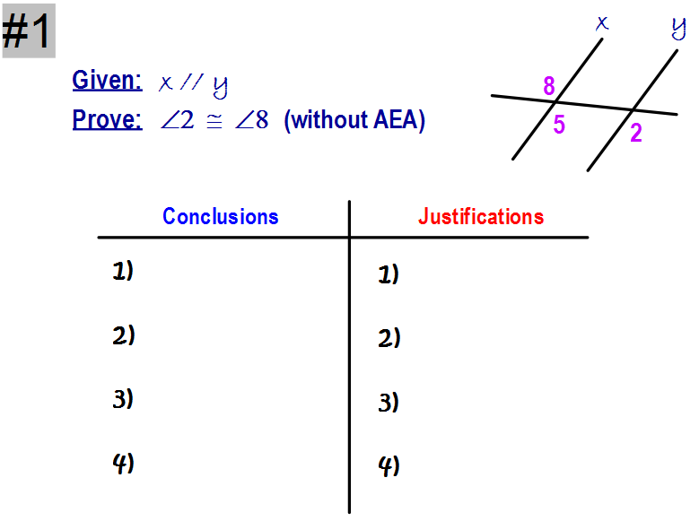

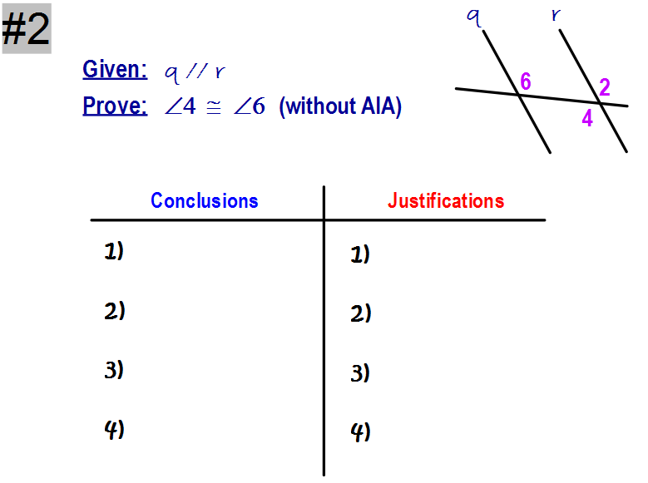

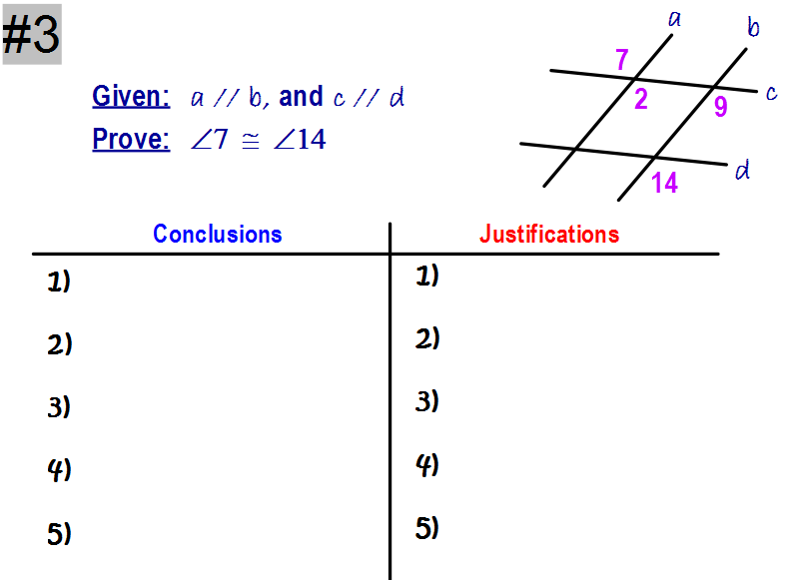

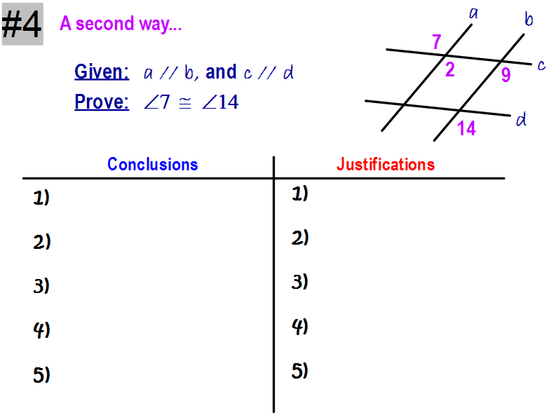

**6) 6)**