Angles in Parallel Lines Name: ________________________________
Date: _____________ Period: ______

Calculate the value of the letters in each question.
151º
e
g
h
f
2)
135º
a
c
d
b
1)

4)
135º
o
s
t
q
r
p
69º
112º
i
k
l
j
m
n
74º
3)

Calculate the values of ALL angles in each picture.

6)
5)
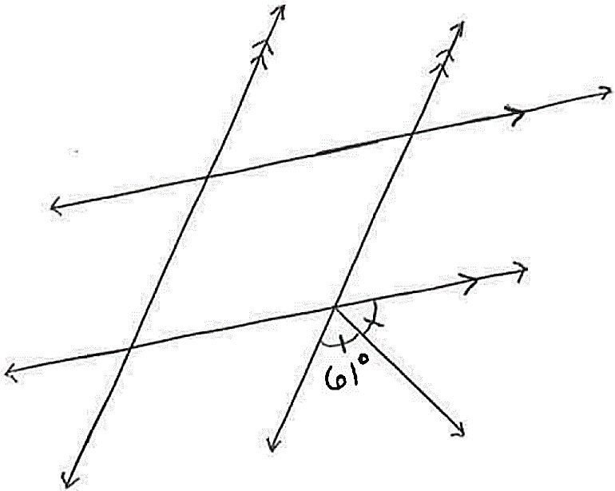
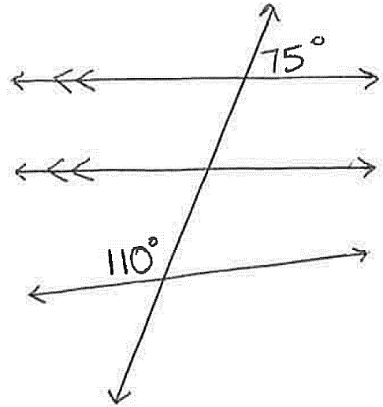

Dinky King – The Next Generation of Platform Game!

I need your help – I was never any good at maths and I’m designing a new game called “Dinky King”. It’s a platform game where my main character, Murrio has to save a damsel in distress by jumping over the barrels rolled down the platforms at him. Murrio climbs the ladders, which will be at different angles, in order to get to the damsel and free her.
All the platforms are parallel with a wedge at each end to make the barrel roll – hope that helps.
We are so close to completing it but I can’t calculate all the angles that the computer programmer needs in order to finish the game. Please find all the missing angles on the game:

