Missing Angles & Angle Algebra Name:_____________________ Date:______ Period:___

For #1-5, solve for all missing measures,

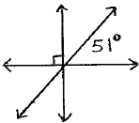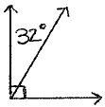1) 2) 3)

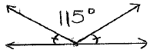

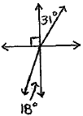

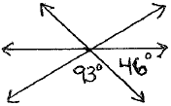4) 5)

For #6-15, solve for x. Then, find the measure of each angle in the picture.

Show you work for each problem!

6.

6x + 7

3x + 2

8.

38x + 20

15x + 1

7.

8x – 51

5x + 15

9. 

*W*

*Z*

*X*

*Y*

9x – 5

6x + 7

10.

4x + 10

11x + 20

11.

3x – 8

5x – 36

6x – 1

7x

12.

14. Challenge:

8x – 6

10x + 8

4x + 2

13.

2x + 3

x + 11

15. Challenge:

4(8x – 1)

23x + 7

14x + 12